Simulation on Demand for Deep Energy Retrofits
Damon Woods, University of Idaho
Alen Mahic, University of Oregon
Kevin Van Den Wymelenberg, University of Oregon
John Jennings, Northwest Energy Efficiency Alliance
Jeff Cole, Konstrukt

ABSTRACT
As a building ages, its components require replacement or retrofitting. Instead of upgrading one component at a time, combining energy efficiency measures in an integrated fashion can yield far greater savings. However, this information is rarely available to building owners. The Spark tool is under development by the Northwest Energy Efficiency Alliance (NEEA) to quickly demonstrate the benefits and cost-effectiveness of performing a combination of energy efficiency measures for a deep energy retrofit on an office building. It provides recommendations on which systems to replace, retrofit, or leave in place based on custom energy simulations run on demand. The tool relies on OpenStudio models and a suite of measures. Two baseline models were created based on actual buildings – one mid-rise and one high-rise office building. The tool includes the selection of four different HVAC designs for replacement or retrofitting as well as upgrade options for plant equipment, plug loads, lighting, and envelope. A web interface allows owners to enter information about their office including the climate, utility bills, and age of equipment. Once the selections are complete, the information is sent to the model which applies the appropriate efficiency measures and the simulation is performed on an external server. The tool generates a report recommending a set of energy upgrades and provides estimates of the potential energy savings and the net present value of performing the upgrades. With this tool, an owner can quickly determine which retrofits would work together best and provide the greatest benefit for their particular building.

Introduction
Building renewal allows owners to capitalize on opportunities and meet investment objectives by attracting tenants, reducing their future risk, and bettering their market position among competing properties. Owners may choose to invest in and retrofit their properties based on market timing, tenant turnover, point of sale, or just to fix broken equipment. However, when an owner decides to retrofit the building, there is a dizzying number of decisions to make about which items should be upgraded and which should be left alone. It can be tempting to do small retrofits in a piecemeal fashion. However, there is a great advantage to performing several energy efficiency upgrades at once (Jiru 2014). For example, if the walls are poorly insulated, and the boiler is in need of replacement, it is most economical to insulate the walls first to reduce the heating load, so that when a new boiler is purchased, the unit can be smaller. While the principle of overlapping efficiency measures can make sense, it can be difficult for owners to know the best course of action for their specific building. To that end, the Northwest Energy Efficiency Alliance is developing a tool that can help with these decisions. The Spark tool enables rapid simulation of measures on demand so that owners can know the best energy efficiency measures to implement for the next 30 years of the building’s life.
The tool is accessed by a web interface where owners may input details regarding their specific building. Based on this information, a match is selected from a database of OpenStudio models. There are a number of measures that are preset in the program, allowing for a custom set to be applied to each new project depending on its needs. Two levels of efficiency are targeted – the first level is a minimum energy savings of 35% over current consumption, the second level of savings calculated is the maximum technical potential at the site based on the Spark tool’s set of measures, with their inherent performance assumptions. The tool also assesses costs and benefits of each of these targets in financial terms familiar to the building owners. This report is centered on the development of the models and the associated energy efficiency measures.

Background
From both an environmental and an economic standpoint, it is often wiser to retrofit an existing building rather than tear it down and rebuild (Preservation Green Lab 2011). Ideally, when considering renovation, an owner would perform a detailed energy and economic analysis of the situation in order to determine which building upgrades are necessary and which are imprudent. However, owners rarely have the time or technical capabilities to do so, and typically are dealing with immediate operational or repair needs. Hiring someone to perform this assessment and analysis work will often require more time and energy than the owners might be willing to devote during the early stages of a project. The Spark tool meets this need. It allows for rapid simulations and scenario testing without requiring owners to download new software or to devote prohibitive amounts of time or resources to the endeavor.
After entering building information into a web interface, users may select various upgrade options and test different combinations of measures. A pdf report is generated with estimates of implementation costs and financial returns from an investment analysis. The way this works is by using OpenStudio Energy Plus models and applying measure scripts that alter the model before simulation depending on each user’s unique selections. The user may then choose to go back and select different options to compare the costs and gains of each scenario.

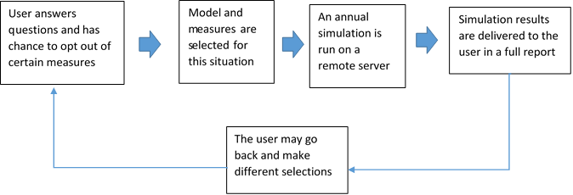
Figure 1. Operational flow of decisions and implementation in the tool with an optional feedback
The origins of this tool began with two demonstration projects in the Pacific Northwest that were intended to lead the way for others. Initially there was a pre-set database that was used, resulting in a database of simulations whose measures could not be altered. This database of about 100 models was used to pair the tool user’s selections regarding building characteristics and owner needs with the closest estimate from the database. However, with over 70,000 different combinations of measures possible, it was determined that a more precise method should be used with more user control. The mid-rise demonstration project had been modeled using EnergyPlus v6.0. The high-rise demonstration project had been modeled in eQuest. Therefore the original models in eQuest and EnergyPlus were transitioned into OpenStudio 1.6 models. Some of the measures were implemented directly from the Building Component Library, while some were developed by the authors for the use of this tool.
The authors are aware of several other simulation-based tools that can also be used for determining building-appropriate retrofits and savings. The challenge of these tools is to balance modeling fidelity without making the tool complex and cumbersome for the user (Lee et al. 2015). One method to avoid simulation run-times and complex inputs is to rely on a pre-simulated database. Such databases are used in the tools C3 Commercial, FirstFuel, and SIMIEN. Simulation on demand allows for a wider array of user inputs. The Retrofit Savings Estimator was developed by the New Buildings Institute and the Weidt Group (NBI 2014). When using the Retrofit Savings Estimator, the user must wait between answering each set of questions for simulations to be loaded for preliminary analysis. This can be cumbersome for users, who wish to answer all the questions in one sitting. The Commercial Building Energy Asset Score Tool is available from the Department of Energy and allows users to input many details of their building including footprint, window to wall ratio, and insulation values. The Energy Asset Score can provide great insight to an auditor with a keen knowledge of building systems, but may be overwhelming for a typical building owner or manager and it does not include cost information. The Commercial Building Energy Saver (CBES) tool from LBNL is a comprehensive retrofit analysis tool that uses EnergyPlus simulations on demand (Hong et al. 2015). This tool is currently designed only for small to medium office buildings although it is under development to handle more building types. With over 100 retrofit options, CBES offers users a plethora of renewal choices for their buildings and boasts higher model fidelity than a pre-simulated approach. The Spark tool that is the subject of this paper also uses simulation on-demand based on user-inputs. Unlike CBES, the Spark tool can also be used for both large and medium office buildings. While each of the previous tools mentioned has great value, the goal of the Spark tool is to fill a particular need: to provide owners of office buildings in the Pacific Northwest a compelling case for performing several renewal measures at once in an integrated fashion. The Spark tool offers simulation on demand for about two dozen retrofit options and includes an economic analysis of the results. The interface is user-friendly and the questions are at a level of detail that provides information about the building without forcing the building owner or manager to pour over old building plans.

Methods
The Spark tool relies on three different pieces to operate: a user questionnaire, an OpenStudio model, and a set of measures that will be applied. This is the heart of the tool that operates behind the scenes of the web interface. While it is invisible to the user, it is the basis of Spark’s energy savings and economic analysis.

Questions
When a user first launches the Spark tool they are greeted with a number of questions about the building. These questions require a general knowledge of the building and its systems including gross square footage, annual energy consumption from utility bills, unconditioned zones, and a basic understanding of the HVAC system.
First, the owner enters a location. The location is used to associate a particular weather file with the simulation. Dozens of typical meteorological year (TMY) weather files from the Pacific Northwest are loaded into the tool’s database. The file that is geographically closest to the building’s location is used. The square footage and number of stories is used to differentiate between mid-rise and high-rise. Any building above six stories is considered a high-rise office building. Questions about system and equipment age are used as proxies for the remaining lifespan of associated equipment that have not been upgraded. This lifespan is used to determine whether a piece of equipment should be retrofitted or replaced with a new piece of hardware. After the general questions are answered, utility information is required –similar to EnergyStar Portfolio Manager.
One question of note is whether the building has a large server room or other major ancillary loads such as cooking, major process equipment, etc. The users are asked to estimate the percentage of total annual electricity and natural gas consumption by these large unregulated loads. For example, one of the major energy uses in modern buildings has become loads associated with data centers or server rooms. These server loads are fairly constant and can account for up to a third of a building’s energy consumption. Because the tool does not include any energy efficiency measures specific to data centers, the tool disaggregates the ancillary load from the rest of the project and adds this usage to the end result to ensure that the tool does not overpromise any savings.
Questions on the building envelope determine the quality of the windows, insulation, and sealing. If a building already has efficient windows or new insulation, then these measures will be applied for the existing condition, but not considered as part of the savings or cost for the project. For an assessment of the current lighting and plug loads in the building, the user is asked to quantify the percentage of high efficiency lights, sensor controls, and LED task-lighting. The questions are phrased as a percentage estimate of building gross square footage, because in many buildings, the lighting and sensors can vary between different tenant spaces within the building.
Replacement of HVAC plant equipment can represent a significant capital cost. Therefore, the users of the tool are given the option to opt out of installing some equipment. Based on the age of equipment, the web tool will display a recommendation, but it is up to the users to select whether they plan to install new HVAC equipment, retrofit it, or leave it as is. The last series of questions include a business analysis that takes into account the current vacancy, the 10-year lease rollover RSF percentages, and the average annual lease rate per year. These are used for the economic calculations to estimate the investment return of the package of measures.
Individual measures are not ranked by their cost effectiveness, nor does the tool report costs on an individual measure basis. Instead, the total renewal costs are presented in Spark’s output. The tool was purposefully designed this way in order to encourage owners to consider renewal projects more comprehensively rather than on a piece-meal basis. The measure costs were determined through the work of Martin Connor of TBD Consultants. Each measure was considered in detail according to regional construction practices and costs. The tool does allow owners to opt out of items that carry a high capital cost such as window or HVAC replacement, but the hope is that the owners will see the advantage of an integrative approach to saving energy so that the measures will work together.

The Models
The models developed in OpenStudio are known as “seeds.” Each seed acts as a starting point for a different building situation. Currently, the tool is intended for commercial office buildings. There are two sizes of building: high-rise and mid-rise. The mid-rise model is used for any building less than six stories. The team chose to use models based on specific buildings in the Pacific Northwest that were representative of the commercial building stock (Cadmus 2009). These buildings served as demonstration projects for this combined Energy Efficiency Measure (EEM) approach. Calibrated models were developed for these two buildings. However, because these buildings are real, they were unique and had only one HVAC system associated with each of them. Thus based on the same loads, vintage, and geometry of the building, several different HVAC systems were modeled. Writing a measure to replace the entire HVAC system for a building can be a challenge. Therefore, different seed models were created for each type of HVAC system that would be appropriate.

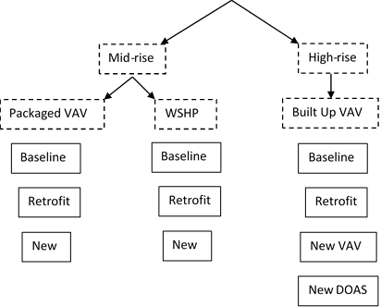
Figure 2. Selection tree of which baseline model the tool begins with. Each solid box represents one seed model
As seen in figure 2, there are ten possible seed models. Each one corresponds to a common HVAC system. One of the downsides to modeling actual buildings was that each had only a single type of HVAC system, and second, some of the building’s components were well above code. For example, the mid-rise demonstration project had an insulation of R-27 – far above what is typical. Therefore the insulation was downgraded to the pre-1980’s CBECs baseline. The schedules and lighting levels were based on a study of an office building in the Pacific Northwest (Duarte, Van Den Wymelenberg, and Reiger 2013). The infiltration flow rate for the models was determined from a blower-door test at the site of the demonstration projects. Baseline infiltration rates for the models will be determined based on a user questionnaire on perceived envelope tightness.
One of the challenges of any retrofit analysis is that each building is unique and will have a different baseline. We started with models of the demonstration projects for our initial baseline and removed any outlying efficiency measures (such as the high insulation value at the mid-rise demonstration project). Next, based on the user’s selection of HVAC type, a baseline “seed” model is used for modeling. The tool does not attempt to match the user’s building with a calibrated model. Instead, because the scope of the tool’s application is narrowed to office buildings in the Pacific Northwest, the demonstration projects serve as rudimentary baselines. Any upgrades the building currently has, will be modeled as pre-existing measures. For example, if the building has LED fixtures in a majority of the spaces, then the LPD measure is applied to the baseline seed, but the cost associated with it is not – because the building already has efficient lighting and the owner does not need to pay for that pre-existing condition. The authors found that as more measures are applied, the closer the final EUI becomes. Because the tool is intended to provide an overview of the magnitude of potential savings and not a guarantee, the authors did not seek to attempt calibration for each user’s baseline. This is also because many older buildings suffer from poor operation in addition to outdated equipment. Therefore, extensive literature is offered to the users on the importance of proper building commissioning whenever considering a retrofit. The baseline model is unlikely to capture operational abnormalities, while the energy model including the retrofits is expected to have undergone commissioning and be operated according to its intended design. Therefore, the tool uses the actual utility bills for the baseline energy consumption, while the simulation results with applied measures are used to estimate post-retrofit energy consumption.

Measures
Based on the user’s inputs, energy efficiency measures are layered on top of the baseline seed models. These measures draw upon past research (NBI 2011) (Liu 2010) and is specific to typical office buildings in the Pacific Northwest. The list of measures include the following:

- Increase wall insulation
- Add a secondary glazing system or install new windows
- Seal the envelope
- Reduce the Lighting Power Density (LPD)
- Install daylight sensor for perimeter zone lights
- Install occupancy sensors for lights
- Replace task lighting with LEDs
- Add occupancy sensors to plug loads
- Install optimized building controls (DDC)
- Add variable frequency drives (VFDs) to pumps on water loops
- Install a new gas condensing boiler
- Retrofit or replace the chiller
- Full HVAC system retrofit or replacement
  - WSHP, PVAV, or VAV retrofit or replacement
  - Replacement of a VAV with radiant heating and cooling and a DOAS

Each measure works in a different way. The insulation measure is implemented in OpenStudio by replacing the exterior wall construction to simulate the effect of adding insulation. The baseline wall is based on a pre-1980 office construction from CBECs. The CBECs baseline was used because the demonstration project had wall insulation well above code. The window measure is similarly modeled. Within each seed model are two construction types: baseline, and upgrade. The OpenStudio measure replaces the baseline constructions with the upgrade definitions. Envelope sealing was modeled by replacing the schedule that OpenStudio refers to for its infiltration parameter. The measure assumes a 50% reduction in infiltration flow as a result of re-sealing the envelope.
While the LPD reduction relied on a measure already within OpenStudio’s Building Component Library (BCL), the authors developed a perimeter daylighting measure. This measure adds a daylight sensor within the model to every perimeter zone and has a daylighting setpoint of 25 ft-candles, a sensor height of 30 inches, with daylighting minimum and maximum power fractions of 0.3 and 0.3 respectively. The authors modeled Occupancy-based lighting control by replacing the lighting power schedule. This new schedule reduced the daytime peak from 95% down to 65%.Plug load adjustments were carried out through BCL measures according to table 1.

Table 1. Measure definitions
Measures | Baseline | Upgrade
Wall Insulation | R-6 [Btu/ft²·h·R] | R-16 [Btu/ft²·h·R]
New Windows | U=0.621[ft²·h·R/Btu]; SHGC =0.41 | U=0.3 [ft²·h·R/Btu]; SHGC =0.28
Envelope Sealing | 0.5 ACHnat | 0.25 ACHnat
LPD Reduction | 1.5 W/ft² | 0.6 W/ft²
Perimeter Daylighting | No sensors | Daylight sensors added
Comprehensive Lighting Control | No sensors | Occupancy sensors simulated through schedule changes
LED Task Lighting | Plug loads defined at 1.5 W/ft² | Reduction in plug loads by 0.1 W/ft²
Occupancy Sensor Controls | Plug loads defined at 1.5 W/ft² | Reduction in plug loads by 20%
Optimized Controls (DDC) | Original Setpoints | setpoints expanded by 1ºF in each direction
VFD on Chilled Water Loop | Const. Speed Pump | Var. Speed Pump
VFD on Hot Water Loop | Const. Speed Pump | Var. Speed Pump
New Boiler | 82% | 93%
Chiller Retrofit | COP: 4 ; Min. PLR: 0.2 | COP: 5.2 ; Min. PLR: 0.2
Chiller New | COP: 4 ; Min. PLR: 0.2 | COP: 5.8 ; Min. PLR: 0.1

The DDC modeling may seem simplistic at first. It uses an existing BCL measure to increase the thermostat dead-band by one degree Fahrenheit in each direction. After the measure runs, the new cooling set-point is one degree higher and the new heating set-point is one degree lower. However, other elements of the DDC savings can be found within each of the HVAC system upgrades. These HVAC upgrades were specific to each type of system. Midrise buildings were modeled with either a Water Source Heat Pump (WSHP) or packaged Variable Air Volume (VAV) system. Upgrades included everything from loop temperatures to supply fan flows. The details of how the HVAC system upgrades were carried out in the models are shown in tables 2, 3, and 4. Efficiencies and insulation values are fixed in the program. While this removes some control from the user, the tool is intended for a high-level analysis only without requiring the user to be familiar with current stretch-code values or expect a higher modeling fidelity than is reasonable with this approach.

Table 2. Water Source Heat Pump System baseline, retrofit, and replacement metrics.
Object | Units | Baseline | Retrofit | New
Cooling Tower |  | Single Speed | Single Speed | Two Speed
Loop Temperature | Cooling ºF | 80 | 85 | 90
 | Heating ºF | 69 | 65 | 60
Ventilation | cfm/person | 30 | 30 | 20
Mixed Loop Pump | Head ft-H₂O | 60 | 60 | 50
 | Motor Eff | 85% | 85% | 90%
HP COP | Cooling | 2.8 | 4 | 4
 | Heating | 3.3 | 5 | 5
OA Operation Schedule | weekday | 7:00-10:00 | 7:00-10:00 | 7:00-10:00
 | Saturday | 8:00-5:00 | 8:00-5:00 | 8:00-5:00
 | Sunday | Off all day | Off all day | Off all day
Furnace Efficiency | % | 80% | 80% | 80%
Economizer |  | No economizer | Has economizer | Has economizer
SAT | ºF | 68 | 68 | 68
Main Supply Fan Efficiency | % | 55% | 55% | 60%
Main Supply Fan Max Flow | cfm | 7,000 | 7,000 | 4,700
Boiler Efficiency |  | 72% | 72% | 95%
Pump Control Type |  | Continuous | Continuous | Intermittent

Table 3. Packaged VAV baseline, retrofit, and replacement metrics
Object | Units | Baseline | Retrofit | New
Gas Furnace Efficiency | % | 80% | 80% | 82%
Ventilation | cfm/person | 35 | 26 | 20
Economizer Control - Fixed Dry Bulb Max Limit | ºF | 65 | 70 | 72
Night Cycle Control |  | Cycle On Full System | Cycle On Full System | Cycle on Terminal Units
Main Supply Fan Efficiency | % | 60% | 64% | 68%
Main Supply Fan Min Flow | % | 60% | 50% | 40%
Main Fan Curve | Coeff 1 | 0.2198 | 0.04076 | 0.04076
 | Coeff 2 | -0.8748 | 0.088045 | 0.088045
 | Coeff 3 | 1.6526 | -0.072926 | -0.072926
 | Coeff 4 | 0 | 0.94374 | 0.94374
DX Cooling Coil Type |  | Single Speed | Single Speed | Two Speed
DX COP | W/W | 3 | 3.2 | 3.5
SAT | ºF | 53 | 53-58 | 53-63
Terminal Units
Terminal Fan Motor Efficiency | % | 50% | 50% | 70%
Terminal Fan Min Flow | % | 30% | 25% | 15%

Table 4. Built up VAV air handling baseline, retrofit, and replacement metrics
Object | Units | Baseline | Retrofit | New
Outdoor Air Economizer Max DB temp | ºF | 70 | 72 | 72
Economizer |  | No Lockout | Lockout with heating | Lockout with heating
Terminal Unit Minimum Airflow Fraction | % | 50 | 35 | 20
Outdoor Air Setpoint Manager | ºF | 55 | 55-60 | 55-60

Results
Once the program runs, the tool produces two simulation results. One result is a simulation based upon the measures selected by the tool user to create a specific deep retrofit scenario and business case, while the second includes the complete set of Spark measures, modeling enhanced savings. The tool estimates these energy savings by comparing the current usage of the real building, to the simulation results after the EEMs are applied. Figure 3 is an example of the energy savings portion of the report that is delivered after the simulation is complete. The output covers the key assumptions made for the economic analysis including the time horizon, consumer price index, capitalization rate, discount rate, and energy cost escalation. The energy performance of the building and potential savings estimated by the tool are shown in terms of the Energy Usage Index (EUI) in kBtu/ft². This information is also broken down into gas and electric usage and the expense of each.
The report generated by the tool can be downloaded as a pdf so that the owner may study the results further without being tied to a computer. The user is also encouraged to opt in to different measures and to run different scenarios on the same building in order to compare estimates of different energy savings and financial benefits. The web tool lends itself to this iterative process so that minimal user effort is required. Also on the Spark website is a technical addendum that can be downloaded. The technical addendum includes further details of each energy efficiency measure so that the user may understand the measure intent and performance assumptions beyond what is provided in the initial report.
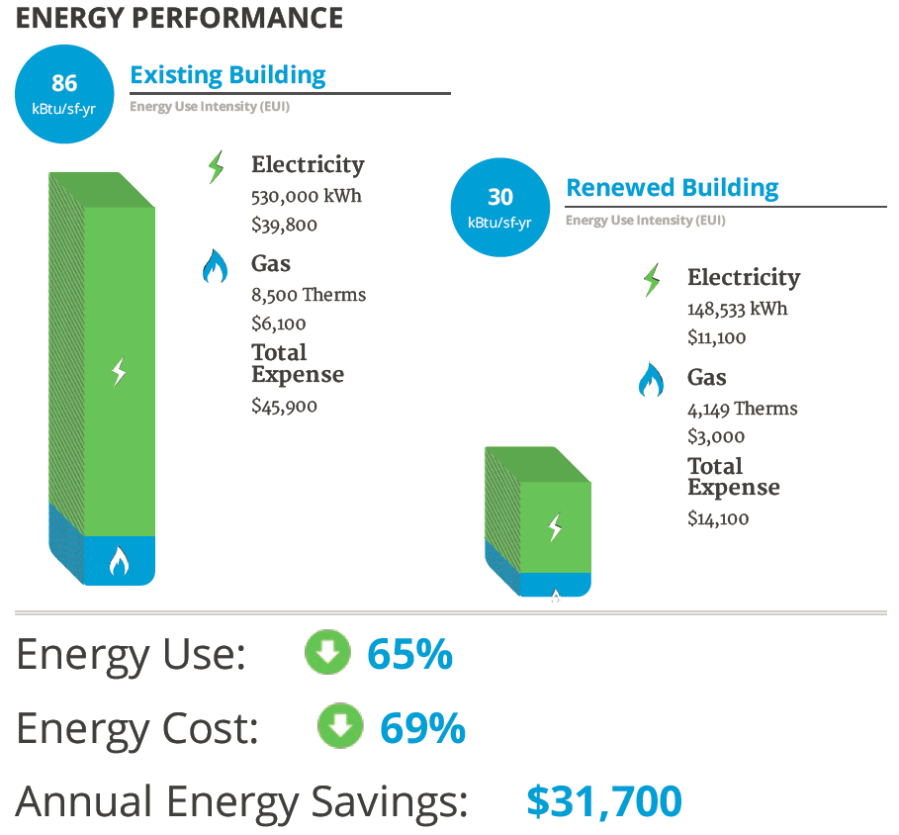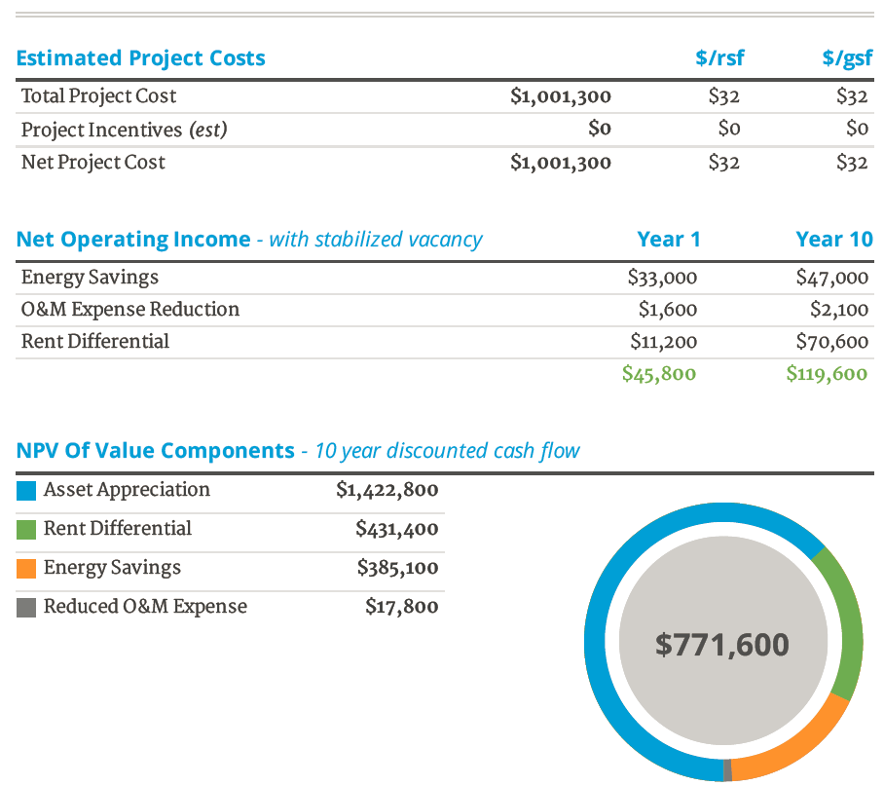
Figure 3. Energy and economic results delivered to the user
Following the energy savings analysis, the report sent to the user provides a short paragraph on each of the individual measures that were simulated, including a write-up on implementation phasing of the projects. The report goes on to list the energy savings and select non-energy economic benefits of implementing the measures, which will be specific to each user. A significant portion of the early work on this project included the economic metrics necessary for the return on investment of these installations. As has been shown in previous studies, the benefit to efficiency upgrades is often much greater than a simple payback from reduced utility bills (Hendricken et al. 2012). Costs for each of these upgrades were determined through price quotes on the demonstration projects and from Martin Connor of TBD Consultants. The economic return calculations and metrics including non-energy benefits were supplied by Molly McCabe of HaydenTanner, a real estate research, strategy, and advisory firm. While Spark’s economic analysis merits a full paper on its own, it is beyond the scope of this particular document.

Conclusions
The goal of the Spark framework is to provide building owners and managers assistance in determining what efficiency upgrades to undertake on an office building. The website developed by Delaris offers an intuitive, user-friendly way of developing a general building model and contrasting savings for various retrofit scenarios. One of the difficulties of estimating the energy savings is that some buildings may not be operating according to the design intent. This difference can lead to either over or under-estimating potential savings. For example, at one of the demonstration projects, the make-up-air unit was not running correctly, so the building was re-circulating the return air without bringing in any fresh outdoor air. This situation resulted in low energy usage for the building, but also unacceptable indoor air quality.
The user guides on the tool recommend first completing repairs and operational fixes, before efficiency capital improvements are undertaken. Without correct operation, it is impossible to know how the building will respond to different efficiency measures. That is why this tool is intended to estimate savings instead of offering a precise prediction. The tool does not guarantee savings, but is intended as a first-step for owners considering renovations. It is meant to highlight opportunities that can then be pursued further under a more detailed analysis. Any potential project is meant to undergo thorough commissioning to ensure that the building may realize the savings from the proposed energy efficiency measures.
During beta testing, the tool underwent a review by Navigant consulting. Based on this review, the tool has been revised to account for some of these ancillary loads and efficiency opportunities. While the building use hours are based on an extensive study of an office in the Pacific Northwest, it could be beneficial to monitor the occupancy of more office buildings within the tool’s designated region to develop a larger sample size to draw upon, or CBSA values could be used. This tool currently has a relatively narrow scope – the renovation of office buildings in the Pacific Northwest. Opportunities exist to use this framework to expand the tool’s application for a wide variety of projects by including other measures, locations, and building-types. Currently the tool dissemination is being piloted by a few utilities in the Northwest. If successful, this will be one vehicle along with dissemination through organizations such as Building Owners and Managers Association (BOMA).

Acknowledgements
This project was made possible through the generous support of the Northwest Energy Efficiency Alliance. The user friendly and visually appealing web interface was developed by Delaris. Tireless project management was coordinated by Konstrukt. Innovative and detailed economic guidance was provided by HaydenTanner. Initial development of the models and measures in EnergyPlus was performed through the diligent work of Ery Djunaedy.

References
Cadmus Group Inc. 2009. Northwest Commercial Building Stock Assessment. http://neea.org/docs/reports/2009northwestcommercialbuildingstockassessment021ca220f212.pdf
Deru, M., 2011. U.S. Department of Energy Commercial Reference Building Models of the National Building Stock. Department of Energy. http://www.nrel.gov/docs/fy11osti/46861.pdf
Duarte, C., K. Van Den Wymelenberg, and C. Reiger. 2013. “Revealing Occupancy Patterns in Office Buildings through the Use of Annual Occupancy Sensor Data” Energy and Buildings 67: 587-595.
Hendricken, L. K. Otto, P. Gurian, J. Wen, and W. Sisson. 2012. “Cost-Benefit Analysis of Energy Conservation Measures.” Simbuild 2012. 5th National Conference of IBPSA-USA. Madison Wisconsin, USA: International Building Performance Association, USA National Chapter.
Hong, T. P., Chen, Y., Lee, S. H., Tylor-Lange, S. C., Zhang, R., Sun, K., & Price, P. (2015). Commercial Building Energy Saver: An Energy Retrofit Analysis Toolkit. Applied Energy, 289-309.

Jiru, T. 2013 “Combining HVAC energy conservation measures to achieve energy savings over standard requirements.” Energy and buildings 73: 171-175.
Lee, S. H., Hong, T., Pietter, M. A., & Taylor-Lange, S. C. (2015). Energy Retrofit Analysis Toolkits for Commercial Buildings: A Review. Energy, 1087-1100.
Liu, G., B. Liu, W.Wang, R. Athalye, D. Moser, E. Crowe, N. Bengtson, M. Effinger, L. Webster, and M. Hatten. 2011. “Advanced Energy Retrofit Guide: Office Buildings”. Technical Report PNNL-20761. Richland, WA: Pacific Northwest National Laboratory.
NBI (New Buildings Institute) 2011, Deep Energy Savings in Existing Buildings Case Studies, New Buildings Institute. http://advanced buildings.net/existing-buildings-case-studies/
NBI (New Buildings Institute) 2012, Getting to Zero 2012 Status Update: A First Look at the Costs and Features of Zero Energy Commercial Buildings, New Buildings Institute.
NBI (New Buildings Institute) 2014, Retrofit Savings Estimator, New Buildings Institute. http://newbuildings.org/resource/retrofit-savings-estimator/
Preservation Green Lab, 2011. The Greenest Building: Quantifying the Environmental Value of Building Reuse. National Trust for Historic Preservation.
RMI (Rocky Mountain Institute) 2014, How to Calculate and Present Deep Retrofit Value, Rocky Mountain Institute. http://www.rmi.org/retrofit_depot_deepretrofitvalue

